Page 1
FLDIGI SETUP MY version 3.22.7 WIN 10 COM 3 COM 4
Feburary 22 2016
As a couple others have got FLDIGI to work with this write up I want to point out something very interesting.
If you are having real problems please UNINSTALL the ALL COM PORTS (hidden ones too) and there is a check YES UNINSTALL DRIVERS in the uninstall question.
REBOOT then install the YAESU USB drivers from the YAESU FT-991 files section.
Then restart FLDIGI and check the options below.
FLDIGI INSTRUCTIONS
Thanks to Jim and Joe.
FT-991 Menu Settings
031 cat rate 38400bps
062 data mode others
064 other dsp ssb 790hz
065 other shift ssb 1500hz
072 data port select USB

FLDIGI CONFIGURATION.
Download the FT-991.xml file from the FLDIGI download XML Archive. DO NOT TRY TO OPEN IT.
Just save it into C:\users\{your login account name}\fldigi.files\rig folder.

RIG CONTROL CONFIGURATION
CONFIGURE > RIG CONTROL
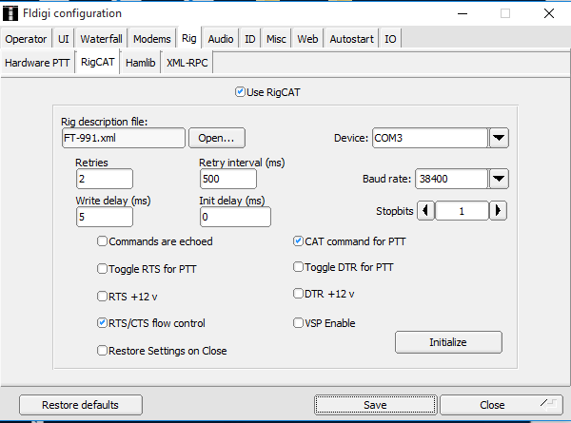

HARDWARE PTT TAB: Use separate rig control – not checked.
RIGCAT TAB: Use Rig Cat – checked
Rig description file: (press the OPEN button, then select FT-991xml.
Retries 2
Retry Interval – 500
Write delay – 5
Device ( com port ) – Use the number of your ENHANCED COM PORT
Baud rate – 34800
Stopbits – 1
Cat Command for PTT = Checked
RTS/CTS flow control – checked
All other boxes unchecked
BE SURE TO HIT INITIALIZE, Then hit SAVE before leaving the TAB.
HAMlib TAB: Use Hamlib check box – Unchecked
HIT SAVE

AUDIO CONFIGURATION: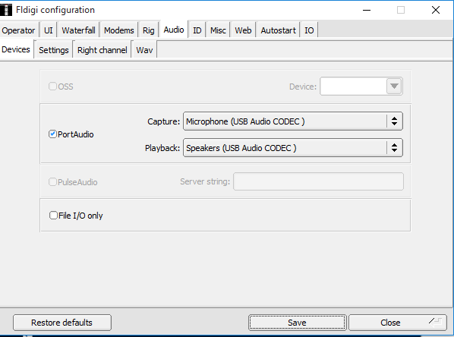
CONFIGURE > AUDIO
DEVICES TAB: Port audio check box – CHECKED
CAPTURE AND PLAYBACK – select USB AUDIO CODEC for the 991 audio driver
Ignore other items on this tab.
SETTINGS TAB: SAMPLE RATE CAPTURE AND PLAYBACK – 48000
CONVERTER – Medium Sync Interpolator.
Corrections – all o
RIGHT CHANNEL TAB: Reverse Left/right channels – CHECKED
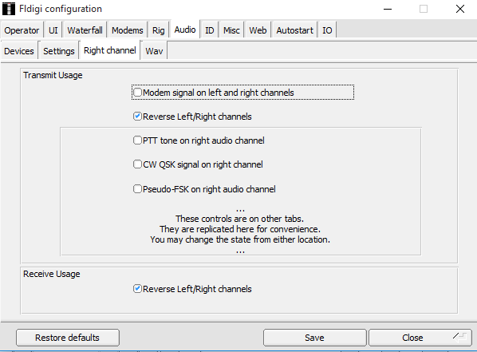
All others Unchecked
WAVE TAB: WAV write samplr rate – 48000
HIT SAVE
THE FLDIGI FREQUENCY BOX SHOULD NOW SHOW THE RIGS FREQUENCY
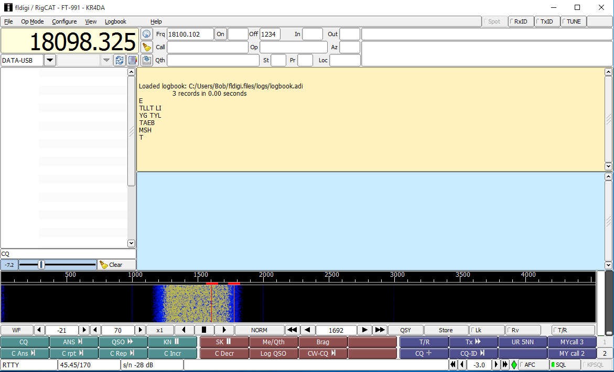
Select OP Mode at top of FLDIGI screen to RTTY. Below frequency readout SET DATA-USB.
Very Bottom left on screen will say RTTY

OPERATION:
RECEIVE LEVEL ADJUSTMENT:
Set the 991 mode to DATA-USB using either the FLDIGI RIG MODE select box or
MODE button on the 991. Should be in DATA-USB or it will not transmit.
Turn up the 991 RF gain control, then use the WINDOWS mixer record control the USB AUDIO CODEC to turn down the waterfall shows mostly blue with some yellow noise spots.
TRANSMIT LEVEL ADJUSTMENT:
Hit the 991 F button, shift through function option and set MONI to on. Adjust to 50
ON FLDIGI, Push the tune button (upper right hand corner of window). You should hear a
Steady tone from the radio speaker. Turn MONI down for a comfortable level.
Using the Windows Mixer for Playback Device, turn down the USB AUDIO CODEC playback slider to show 50 watts on the 991 power meter. Then select the ALC meter and press the DT GAIN button and adjust the MULTI KNOB for no ALC indication. (you may use the DT gain for fine level corrections during operation. Adjusting the RF GAIN will be used a lot during receive.
UNKEY FLDIGI

FT-991 FUNCTION ADJUSTMENTS
Hit the F button on the 991. Shift the options buttons until you find NAR/WIDE button.
SET IT TO WIDE.
Now move the options buttons until you find the WIDTH button. Press it to turn and turn
The MULT knob until the width reads 3000HZ. (this will also be used in receive mode for fine adjustments.)
This should show a blue background on the FLDIGI waterfall from about 200 to 3000 HZ.
You should be ready to operate FLDIGI. (turn off the MONI if you wish.) I like it on.
If you save this frequency to a memory, the DATA-USB Mode and the function selections will all be saved.

Disclaimer: it was on original write up. AT YOUR OWN RISK. It worked for me.

Some of my additional experiences note.
DATA-USB is set under the freq readout on FLDIGI I keep it set to that for everything.
FLDIGI SCREEN under the freq readout there is a option: OP MODE. This is where I set CW, RTTY, and packet modes.
As you change these modes the lower LEFT corner will reflect the change.
The 991 RF gain I use to control the waterfall blue yellow issues. TO much gain to much yellow.
Time practice will get you going. MACROS you will reset and use your own. I have never used SOUND card modes before, I always used HARDWARE. Very impressed with these current programs.
Again thanks to the guys who helped me get on the air.
De KR4DA Bob

